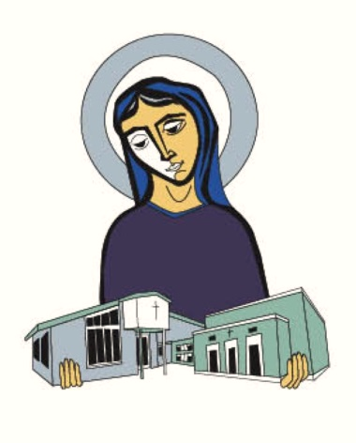
Volunteer Credit Voucher – Mary of Lourdes School
Service description:____________________________________________________________
Date(s) of service:________________________ Chairperson for service: __________________
Volunteer Name:_______________________________________________________________
# of credits:_____________ Family receiving credits:_______________________________

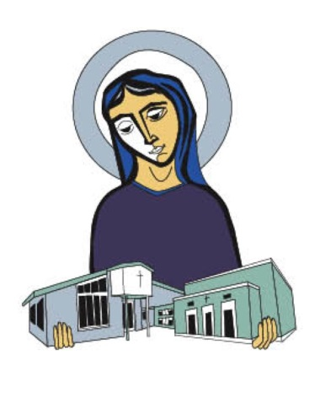
Volunteer Credit Voucher – Mary of Lourdes School
Service description:____________________________________________________________
Date(s) of service:________________________ Chairperson for service: __________________
Volunteer Name:_______________________________________________________________
# of credits:_____________ Family receiving credits:_______________________________

Volunteer Credit Voucher – Mary of Lourdes School
Service description:____________________________________________________________
Date(s) of service:________________________ Chairperson for service: __________________
Volunteer Name:_______________________________________________________________
# of credits:_____________ Family receiving credits:_______________________________

Volunteer Credit Voucher – Mary of Lourdes School
Service description:____________________________________________________________
Date(s) of service:________________________ Chairperson for service: __________________
Volunteer Name:_______________________________________________________________
# of credits:_____________ Family receiving credits:_______________________________

